**DAILY ONLINE ACTIVITIES SUMMARY**

|  |  |  |  |  |  |  |  |  |
| --- | --- | --- | --- | --- | --- | --- | --- | --- |
| **Date:** | **18-06-2020** | | | | | **Name:** | **ROUSHA** | |
| **Sem & Sec** | **6 B** | | | | | **USN:** | **4AL17CS079** | |
| **Online Test Summary** | | | | | | | | |
| **Subject** | |  | | | | | | |
| **Max. Marks** | |  | | **Score** | | |  | |
| **Certification Course Summary** | | | | | | | | |
| **Course** | **1.Preplacement Training**  **2.Python workshop on DA and ML** | | | | | | | |
| **Certificate Provider** | | | **____** | | **Duration** | | | **4 Hours** |
| **Coding Challenges** | | | | | | | | |
| **Problem Statement: 1 Python Program** | | | | | | | | |
| **Status: Executed** | | | | | | | | |
| **Uploaded the report in Github** | | | | | **Yes** | | | |
| **If yes Repository name** | | | | | https://github.com/rousharousha/DailyReport.git | | | |
| **Uploaded the report in slack** | | | | | **Yes** | | | |

Online Test Details: (Attach the snapshot and briefly write the report for the same)

Certification Course Details: (Attach the snapshot and briefly write the report for the same)

Attended class on the topic programming in C. [9:15am to 10:45am]

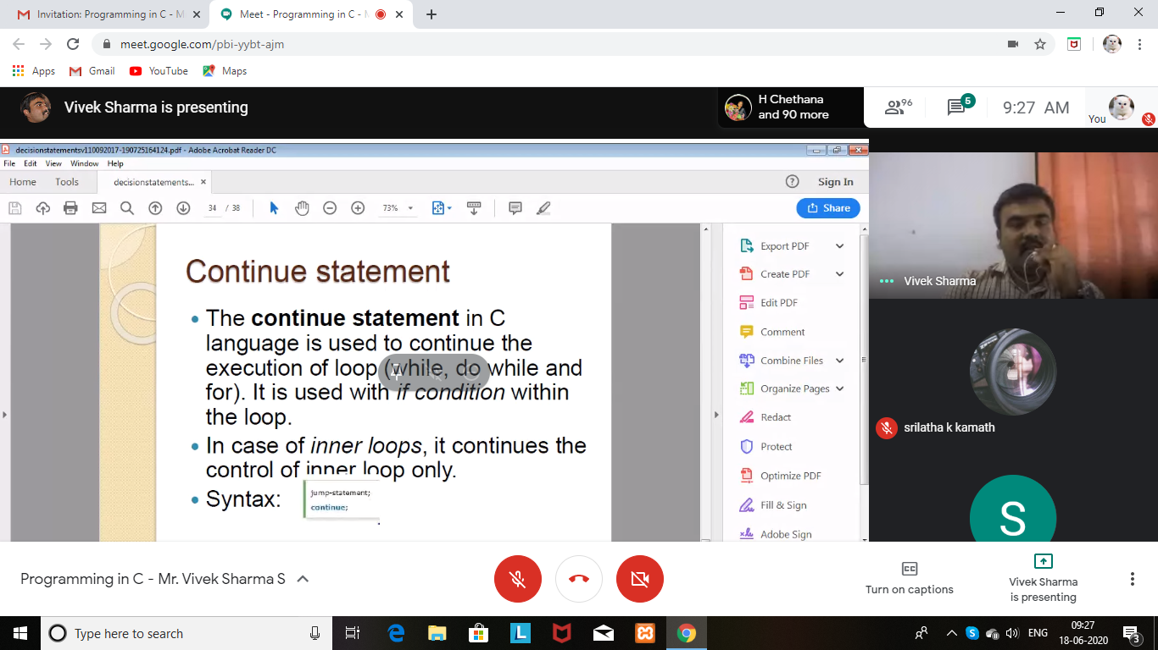

Attended python workshop on DA and ML. [10:45am to 1:30pm]

Worked out python programs using google colab.

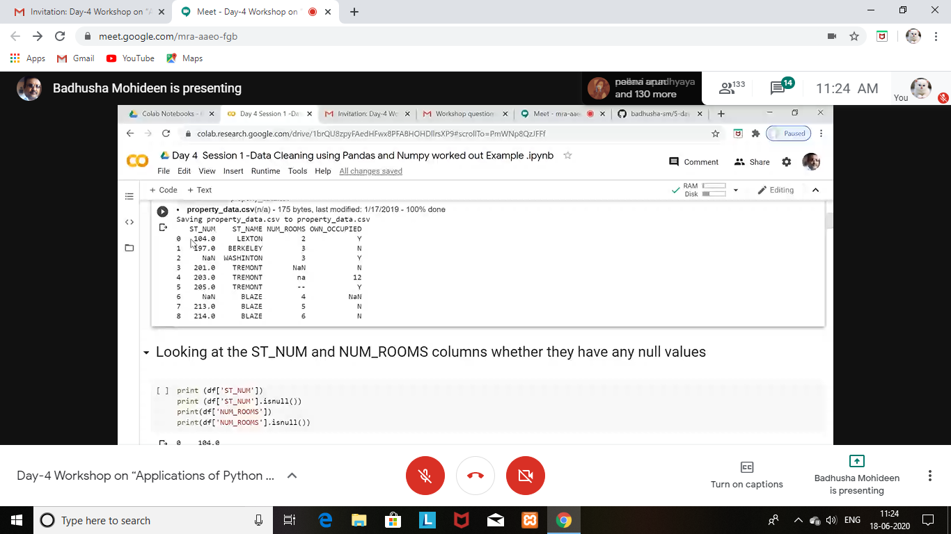

Coding Challenges Details: (Attach the snapshot and briefly write the report for the same)

Program1:

